
STUDENT CASE STUDY EXECUTION REPORT
Department | FED
Subject | DSA -2
Academic year | I – III Semester(2025-26)
Faculty Name | V. GopiKrishna
Student Name | K. Sriram
Roll Number | 2520040072
Branch | ECE
Course Outcome | 3

Case Study Topic : EventSphere Venue Accessibility Analysis using Breadth First Search (BFS)
EventSphere is a smart event planning and management system used to manage event schedules, participant registrations, venue bookings, and venue accessibility.
Large events are often conducted across multiple connected venues.
To help organizers and participants move between venues efficiently, EventSphere stores venue connections as a graph.
Each venue is represented as a vertex.
Road/path connections between venues are represented as edges.
For one technical event, the venue network is:
Venue Number | Venue Name
0 | Main Hall
1 | Seminar Hall
2 | Auditorium
3 | Workshop Lab
4 | Exhibition Hall
Connections:

0 – 1
0 – 2
1 – 3
2 – 4

Starting from Venue 0 (Main Hall), EventSphere must check all accessible venues.
Breadth First Search (BFS) is used.

Question
Using the EventSphere venue accessibility scenario above:
- Represent venues as graph vertices
- Add connections as edges
- Start BFS from venue 0
- Visit connected venues level-by-level
- Show traversal order
- Calculate worst-case search time
- Explain why BFS is suitable

Analysis & Implementation

1.1 Graph representation
Vertices:

0, 1, 2, 3, 4

Edges:

0 – 1
0 – 2
1 – 3
2 – 4

Graph structure:

0
/ \
1 2
| |
3 4

1.2 BFS traversal
Starting node:

Venue 0

Traversal order:

0 → 1 → 2 → 3 → 4

Explanation:
- Visit 0
- Queue 1 and 2
- Visit 1
- Queue 3
- Visit 2
- Queue 4
- Visit remaining nodes
All venues become accessible.

1.3 Time complexity
Breadth First Search:

O(V + E)

Where:
- V = number of venues
- E = number of edges
For EventSphere:

V = 5
E = 4

So:

O(5 + 4) = O(9)

1.4 SLA calculation
Given:
- One traversal operation = 200 ns
- Budget = 5 ms
Total operations:

9

Worst-case:

9 × 200 ns = 1800 ns

Convert:

1800 ns = 0.0018 ms

Percentage:

(0.0018 / 5) × 100
= 0.036%

System satisfies SLA.

1.5 Why BFS is suitable
Advantages:
- Visits nearest venues first
- Efficient accessibility checking
- Works well for connected venue networks
- Easy path expansion
- Fast traversal
For EventSphere:
- organizers know reachable venues
- participants navigate easily
- venue mapping becomes efficient

2. Final reasoning
For EventSphere:
- venue graph stored correctly
- BFS visited all connected venues
- traversal fast
- low processing time
- suitable for venue accessibility analysis

Code:
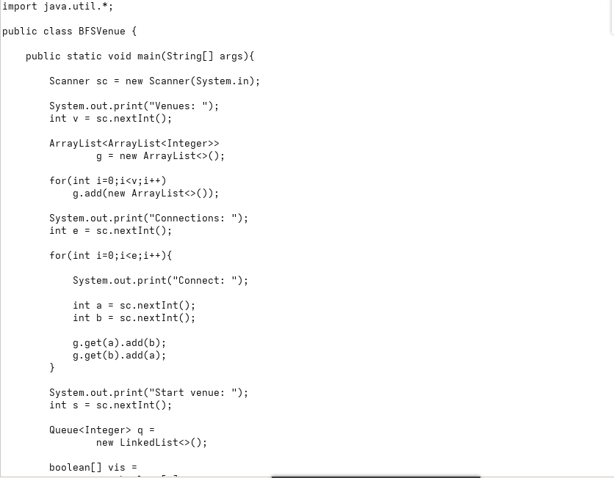

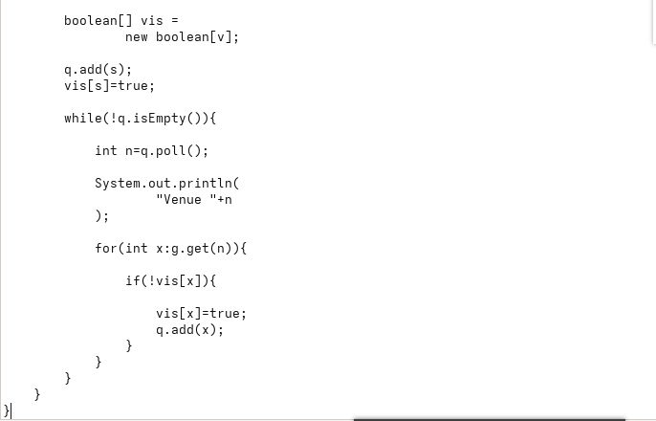
Output:
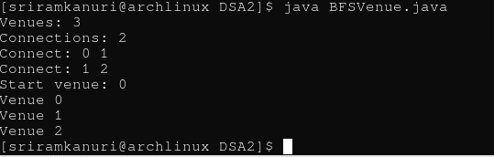

GitHub Link: https://github.com/kanurisriram/EventSphere

Student Signature | Faculty Signature
____________________ | ___________________

